Assignment 1 Portfolio CSP2101

Scripting Languages

Ciaran Fereday

#10393236

The line and output for

echo " Secret Number for testing = '$NUMBER'"

shows the generated number and is there to make the testing easier

Screenshots of output

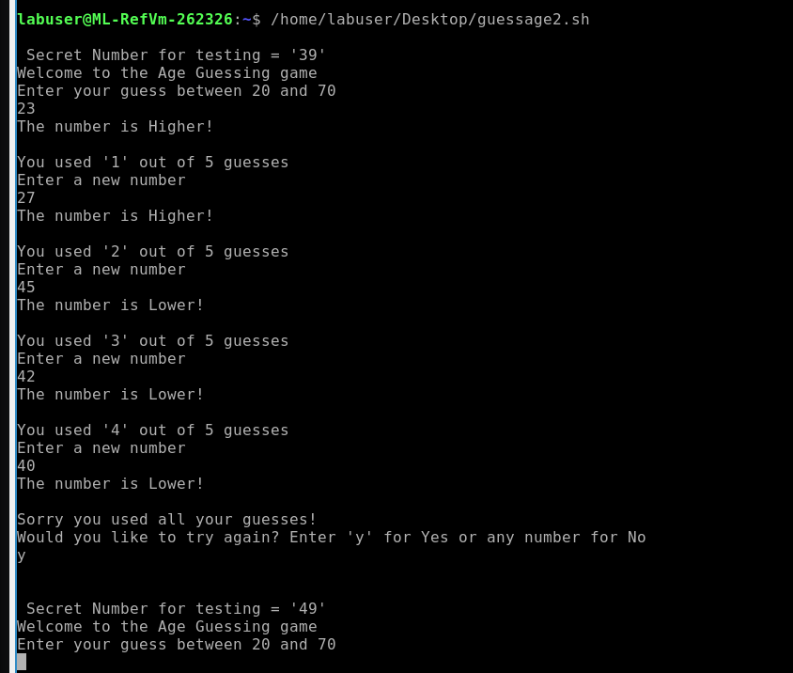

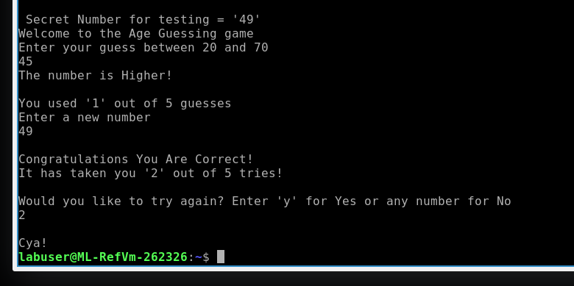

Code for guessage

#Assignment 1.1

# Ciaran Fereday

#Scripting Languages

#10393236

#!/bin/bash

NUMBER=0

GUESS=0

startGame() #create a function called startGame

{

NUMBER=$((20 + $RANDOM % 50)) #Generate a random number between 20 and 70

echo ""

echo " Secret Number for testing = '$NUMBER'"

echo "Welcome to the Age Guessing game"

echo "Enter your guess between 20 and 70"

read GUESS #Store the users input in a variable called GUESS

checkGuess #load the checkGuess function

exit

}

checkGuess()

{

NUMGUESS=$1 #first command line argument

NUMGUESS=$((NUMGUESS+1)) #NUMGUESS adds 1 every time it is called again

if (($NUMBER == $GUESS)); then #if the random number is equal to the guess

endGame 1 $NUMGUESS #go to the first argument in the function endGame

fi

if (($NUMBER > $GUESS )); then #if the number is greater then the guess

echo "The number is Higher!"

echo ""

fi

if (($NUMBER < $GUESS)); then #if the number is lower then the guess

echo "The number is Lower!"

echo ""

fi

if (($NUMGUESS == 5 )); then #if the number of guesses equals 5

echo "Sorry you used all your guesses!"

endGame 2 $NUMGUESS #skip the first parameters in endGame and go to the second

fi

echo "You used '$NUMGUESS' out of 5 guesses" #show how many times you have guesses

echo "Enter a new number"

read GUESS

checkGuess $NUMGUESS

}

endGame()

{

#NUMGUESS=$2

if (( $1 == 1)); then #if the first paramaters are met

echo""

echo "Congratulations You Are Correct!"

echo "It has taken you '$NUMGUESS' out of 5 tries!"

echo ""

fi

NUMGUESS=$2 # if the second parameters are met

echo "Would you like to try again? Enter 'y' for Yes or any number for No"

read TRY #assign the user input to TRY

if (($TRY == "yes" )); then #if a letter is typed

echo ""

startGame #start the whole game again

else #if a number is typed

echo ""

echo "Cya!"

exit #end the game

fi

}

startGame